PANCAR WAHYU SETIABI

H1D024018

SHIFT D

1. Insert data into table

MariaDB [penjualan_barang]> insert into barang values

-> ('12345', 'PS 5', '2000', '5');

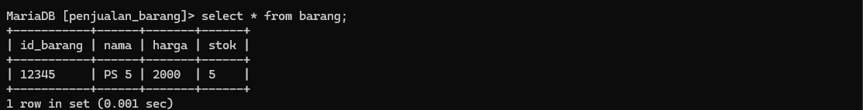Query OK, 1 row affected (0.007 sec)

1. Delete data dari table

MariaDB [penjualan_barang]> select * from barang;

+-----------+------+-------+------+

| id_barang | nama | harga | stok |

+-----------+------+-------+------+

| 12345 | PS 5 | 2000 | 5 |

| 56789 | PS 6 | 3000 | 6 |

+-----------+------+-------+------+

2 rows in set (0.001 sec)

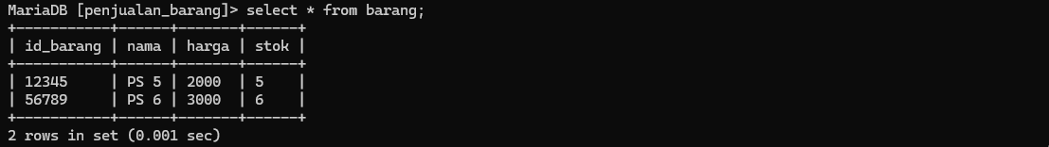

MariaDB [penjualan_barang]> delete from barang where id_barang='56789';

Query OK, 1 row affected (0.003 sec)

